ITEC3250

Assignment 4

100 pts

Due 10/15

Dr. Jonathan Jenkins
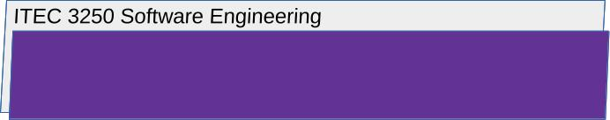

Requirements

1 Notes
- Number your responses as in the writeup, whether response is included or not
- To assist me in efficient scoring, use this document as a template, typing in your responses to each question.
- Your attention to detail in concisely and completely answering the question will determine your score

2 This Assessment Covers

- Software Testing, with Textbook Chapter 8
- Software Evolution,with Textbook Chapter 9

3 What to Submit
lastnameFirstinitialA4.docx

All submitted files must be named with your first and last name as shown

Answer the Following Questions

4 Part 1 Software Testing, with Textbook Chapter 8

- For the following numbered cases, argue whether program source code inspection by human engineers or formal software testing should be used to discover and fix the issue
  - A software system is designed to rank job candidates by processing resume information. This system is currently producing incorrect categorizations and rankings that do not match the hiring organization’s requirements.

5 Part 2 Software Evolution, with Textbook Chapter 9

- Suppose that the job candidate ranking system described above has completed development, testing, has been deployed for use in real organizations and completed a few years of maintenance. However, competition from artificial intelligence-based tools has recently appeared.
Briefly argue which of the numbered options given below (or a combination?) is the best choice for the evolution of this software system.
Support your argument with factors discussed in the chapter
Review textbook chapter 9, section 9.2.1
  - Scrap the system
  - Continue with regular maintenance
  - Reengineer
  - Replace all or part of the system with new code.

6 Submission
For submissions to submission folders:

- Submit using the submission folder in D2L for this assignment
- For every assignment, create a new file to produce the submission
- Requirement: download or retrieve your submission after you submit it in order to check that your files are as you intend to be scored
- Resubmission is possible while the folder is open
- Latest scoreable submission is scored

